Password Management Application

Submitted in partial fulfillment of the requirements

of the degree of

Bachelor of Engineering

by

Yash Sawant Roll No. 40

Manas Raut Roll No. 36

Vignesh Pillutla Roll No.27

Mihir Singh Roll No.49

Supervisor:

Prof. Suchetadevi Gaikwad.

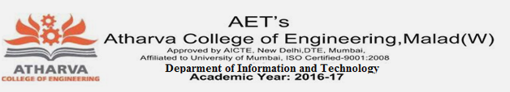

Department of Information Technology

Atharva College of Engineering

Year: 2020-21



**ATHARVA COLLEGE OF ENGINEERING**

**MALAD (W), MUMBAI 400 095**

**YEAR: 2020-2021**

CERTIFICATE

*This is to certify that*

**Manas Avinash Raut (Roll No. 36)**

*have submitted the Mini Project report for the requirements of the Bachelor of Engineering in Information Technology satisfactorily*

on

**“Password Management Application”**

*As prescribed by the* ***University of Mumbai*** *Under the guidance of*

**PROJECT GUIDE H.O.D. PRINCIPAL**

**INTERNAL EXAMINER COLLEGE SEAL EXTERNAL EXAMINER**

Approval for S. E. Mini Project Report

This project report entitled Password Management Application by **Manas Avinash Raut** is approved for the degree of ***Bachelor of Engineering in Information Technology***

**Examiners:**

* 1. -----------------------------------

(Internal Examiner Name & Sign)

* 1. -----------------------------------

(External Examiner Name & Sign)

Date: 08/12/2020

Place: Mumbai

**Contents**

**Abstract**

**1.** **Introduction**

**1.1** **Introduction**

**1.2** **Motivation**

**1.3 Problem Statement(2 to 3 lines)**

**1.4 Objectives(1 or 2 lines)**

**2.** **Literature Survey**

**2.1 Survey of Existing system**

**2.2 Limitation Existing system or research gap**

**2.3 Mini Project contribution**

**3.** **Proposed System**

**3.1 Architecture/Framework**

**3.2 Algorithm and Process Design**

**3.3 Software Requirement Specification**

**3.4 Implementation Code(write classes as heading)**

**3.5**  **Output Screenshots(with title of each output)**

**4.**  **Conclusion(5 to 6 lines)**

**5. Future work**

**References (include IEEE Paper names. No Wikipedia.com, google.com)**

**Acknowledgement**